42 class
Fist lauch a vm remove all existing docker packages if any

sudo dnf remove docker \
docker-client \
docker-client-latest \
docker-common \
docker-latest \
docker-latest-logrotate \
docker-logrotate \
docker-engine \
podman \
runc
after run below commands

this are the redhat
sudo dnf -y install dnf-plugins-core
sudo dnf config-manager --add-repo https://download.docker.com/linux/rhel/docker-ce.repo

sudo dnf install docker-ce docker-ce-cli containerd.io docker-buildx-plugin docker-compose-plugin

sudo systemctl enable --now docker

then check systemctl status docker

in the root user docker ps command will execute & but with non sudo user docker ps command will not execute

when docker installed docker group automatically created

usermod –aG docker ec2-user

Part | Meaning
usermod | User Modify - command to modify user account settings
–aG | Append to Group - two options combined (-a + -G)
docker | The group name to add the user to
ec2-user | The username being modified

Vm logout & login then with nonsudo user docker ps command will execute

VM AMIINSTANCE
DOCKERIMAGECONTAINEr
+

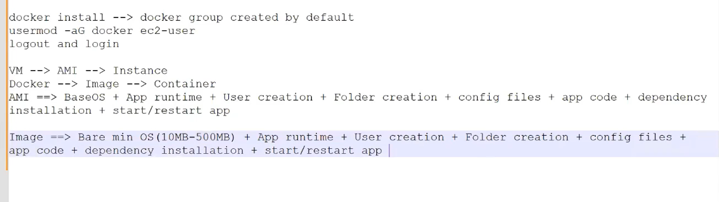

Docker ps : Display the running containers
Docker imgages : display the available images

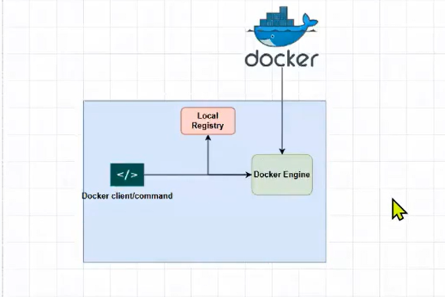

Docker create nginx:lates:: create a container from image
Docker ps –a: display the all running & stopped & started containers
Docker start containerid : that container will start
Docker rm containerid : running container can’t remove
Docker rm –f coninerid : -f means forcing container then it will removed container
Docker rmi imageid
Docker images –a –q : display the all images –a all images –q image id
Docker rmi `docker images –a -q`:: remove all the images

Docker run nginx

Docker run –d nginx : -d means detach the screen

Docker pull +create+start===docker run nginx it is blocking foreground then use the
Docker run –d nginx it will run the background

+++++++++=
Docker run –d –p 80:80 nginx
Host port : container port
Docker exec –it container id bash : it will go to the conainer
Docker logs containerid
Docker inspect containerid

43 class

$ docker run –d –p 80:80 –name my_nginx nginx
$docker exec –it my_nginx bash
$ docker inpect my_nginx
$ docker logs my_nginx

How to create custom docker images ?
Docker file used to create our custome images using instructions provided by docker

RHEL9==CENTOS9==Almalinux
FROM
FROM <BASE-OS>:<VERSION>

